Posted 11/06/2014 at 9:43 am by JAV

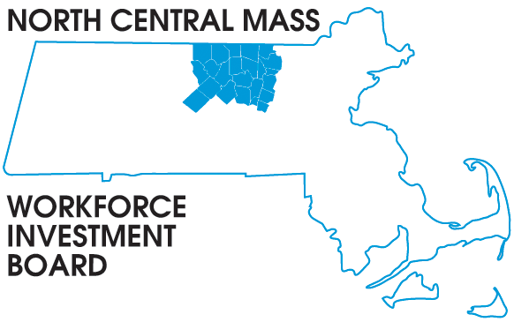
1355 Central Street Leominster, MA 01453 Phone: (978) 534 1023 Fax: (978) 534 1807

BOARD OF DIRECTORS MEETING

Tuesday, November 18, 2014

North Central Chamber of Commerce
860 South Street Fitchburg, MA
8:00 a.m. – 9:30 a.m.

AGENDA

Welcome & Introductions

Approve Minutes of the September 2014 meeting (Vote required)

Executive Committee report Martha Chiarchiaro (Vote required)
Finance report Barbara Mahoney

Recognition of retiring Board Member
David McKeehan

Presentation: DEI V USDOL Disability Grant
Theresa Kane

Grant Updates
2014 School to Career Connecting Activities: Mike Gerry
HI-B: Wendy Storm
WCTF Manufacturing Training: Rosemary Chandler

Directors Report: Grant opportunities & Workforce in the NEWS

Other Business

